kaft + gegevens

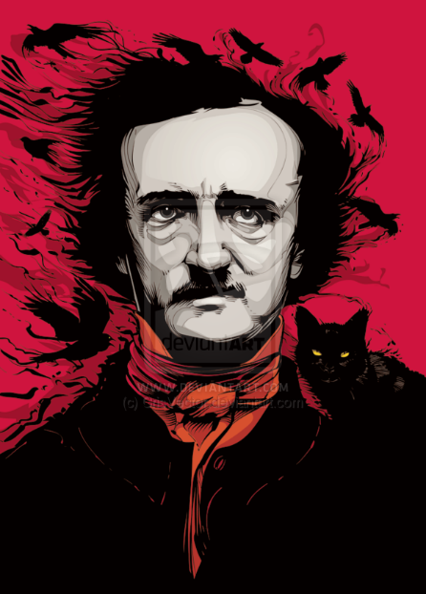
Foreword
After having read my first short story, The Chapel by Essberger, I thought they wouldn’t come any stranger. It turned out, they would.
I already knew the writer of this short story, Edgar Allan Poe, was known for his dark writing. I expected something twisted or unusual, but the level of twistedness still surprised me.
Already knowing the story was rather old, I expected to find an old use of English. I learned from the past, that I could have difficulties with old English, so I wondered if that would work against me this time.
Summary
From his infancy, the main character has lived with animals.
At first, he adored and took care of them, Pluto, his favourite cat in particular. At a later age, he developed an alcohol problem, which led to hatred and loathing of his pets. He started abusing them. During a certain, drunk evening, he even cuts the eye of his favourite cat out.
His wife, who he is happily married to, doesn’t intervene in these abuses. One terrible morning, the man murders his cat by hanging it by its neck. That night, the house was set ablaze, destroying it completely, with the exception of one wall on which the figure of a cat had appeared. This figure seemed to have a noose attached to its neck.
A period passed, in which the man was content with his deed. He couldn’t help but keep an eye out for a similar cat like Pluto, which he happened to come upon while drinking.
He took the cat home and adored it like it was Pluto. This didn’t last long, the man quickly returned to his old habits.
During a household chore, he tried to murder the cat. When his wife stopped him, he lost control and murdered her instead. He then decided to get rid of the corpse by walling it up in the basement.
When the police arrived for their investigation, he accidentally gave himself away by knocking on the wall and thus scaring the walled up cat. It appeared he had walled up the animal with the corpse.
Themes
-hatred;
-murder;
-insanity;
-psychological disorders;
-projecting blame;
-lack of guilt;
-physical abuse;
-alcohol abuse;
-black cats;
-superstition.
The main theme in the story, in my opinion, is ‘psychological disorders’.
The actions of the main character and the way he handles every situation, clearly show signs of one or more psychological disorders. Not being an expert on the case, I think it’s clear that the actions of the main character are not healthy and in common times I’d think the person would be heavily treated or locked up.
The major character himself would never acknowledge having a disorder. At the beginning of the story, it becomes clear that he knows he did a horrible thing. This is shown by the way he writes his letter from prison. In the story itself though, the major character seems to think he’s an average man and blames all the misery to the cat.
Another theme that deserves attention is ‘hatred’, or malevolence, like the story calls it in a posh way. The word hatred is used frequently in the story and is the main drive for the man to do the horrible things he does. The author goes into depth about this subject.
Analysis of major characters
The story doesn’t mention a name or age of the major character.
The story gives a thorough view on his mind and perspective, but doesn’t give any personal information. For me, this makes it hard to form an image of the character and his environment.
I also found it rather strange to read along with a person who does such cruel things and thinks so lightly of it. I got dragged along with a person which I could hardly identify with.
The major character developed from an animal loving person to an abusive drunk, without the storyteller giving a reason why.
The character committed the following acts of cruelty:
-it started with hating and beating his pets;
-he physically abused his wife;
-he stabbed his cat’s eye out;
-he hung the cat from a tree;
-he repeated the process with other cats;
-he found a similar cat and developed the same hatred again;
-he murdered his wife with an axe (while trying to kill his cat);
-he walled his wife’s corpse (and cat) up in the wall.
Although through the story he didn’t show any kind of remorse, nor was he able to understand the severeness of his actions, after all the events he understands his wrongdoings.
Important quotations explained
1. ‘I blush, I burn, I shudder, while I pen the damnable atrocity.’
-main character about the moment where he cuts out the eye of his cat-
I chose this quotation because I think it’s well written. It shows the remorse the main character has in prison, looking back on his actions.
What I like about the sentence is the fact that you can interpret it in two ways. At first I thought the author referred to the pen-knife stabbing the cat’s eye. But while discussing the matter with the class, we found out the author could also have meant ‘writing about the terrifying action’.
2. ‘Yet I am not more sure that my soul lives, than I am that perverseness is one of the primitive impulses of the human heart- one of the indivisible primary faculties, or sentiments, which gave direction to the character of men.’
-main character about the feeling of perverseness-
This sentence is truly what English literature is to me. What I like most is the darkness that Edgar Allen Poe brings alive in this story.
While reading, we interpreted the word as ‘perversion’. It sounded fitting in the context of the story because what was described was the exact definition of the word, without using the word itself.
Later, we found out that perverseness means something entirely different.
This is one of the most common excuses the main character uses for his actions. This is a major plotpoint. The following quote backs this up: ‘Who has not, a hundred times, found himself committing a vile or silly action, for no other reason than because he knows he should not?’
What I like about this last quote, is that the author is able to explain something, without really revealing the true nature of the actions.
Author
Edgar Allan Poe, from here on referred to as Edgar, was an American writer. This fact confused me quite a lot, because I was certain he was a British writer. While discussing this, a classmate of mine noticed that the United States as we know them didn’t exist back then. The states he lived in were Boston and Maryland, which at that time were some of the states that declared themselves independent from Great Britain.
He also studied in England in his youth.

